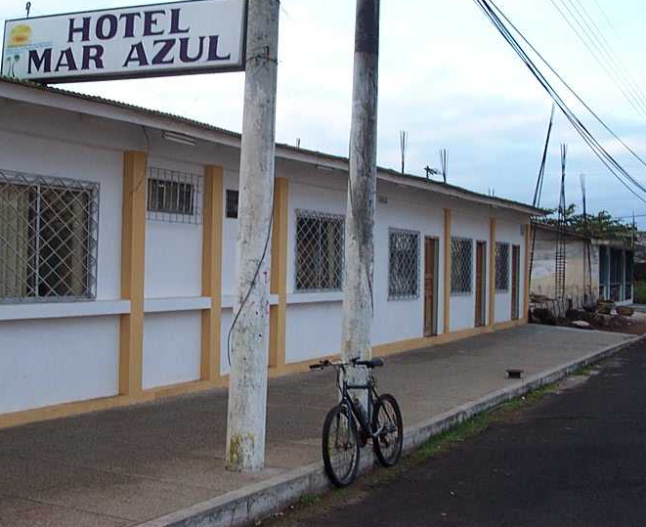
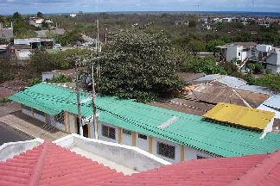
South East facade of Mar Azul hotel Fig 1: South East facade and tree in the atrium

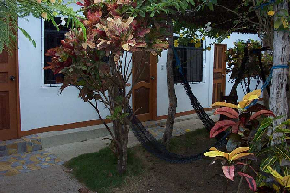
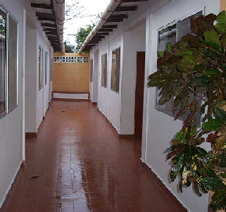

Fig 2: Internal atrium Fig.3 : Main open corridor close the atrium

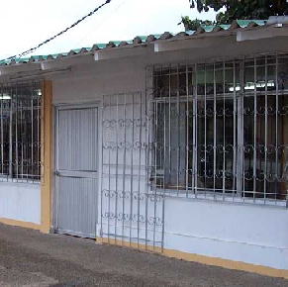
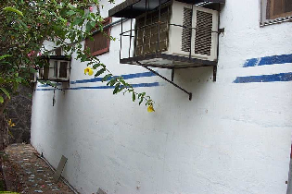
Fig. 4 : A detail of corrugated panels of the new roof Fig. 5 : air conditioning units in the hotel rooms

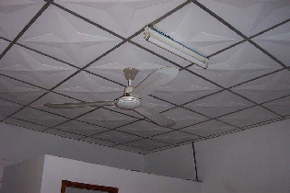
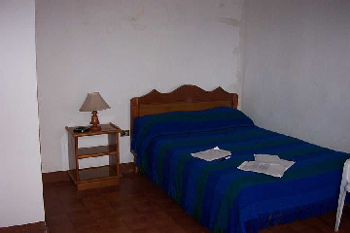
Fig. 6 : Ceiling fan in a hotel room Fig. 7 : Incandescent luminary in the hotel rooms

